Hello ,
Thank you for contact us, you are one of those who answered our survey, We are students at princess Nourah University , we made a survey about (back pain and positional problems).
First of all , we want to let you know that you are one of many people who have a back pain which affected your Active daily activities. IF you did not take care of it , it may cause serious problems, such as Spinal problems ( Kyphosis-lordosis-Scoliosis )
from your answers we found that :
** relax your muscles through :
Take rest after your duty or any physical stress
Hot packs (for 10 min )
Warm bath
** You should modify your life style through:
- exchange your hand bag with a back bag (not heavy )
- When you sit in front of TV, be careful about your position, with change your position every 10 min. and try to make it less than 2 hours.
- You should intermittent your sitting in front of computer, then you should do some exercises each half hour while you are sitting in front of your computer, here we found a video that may help you to learn how to sit well and some simple exercises you can do it daily :
http://www.youtube.com/watch?v=eRgwyLTUbR0

- Try to manage your work to avoid being physically or physiologically stressed which may lead to muscle spasm and further problems.
- Watch your posture during sitting& sleeping, try to fix your position and maintain it, through add roll (towel & pillow may used) behind your trunk during sitting & under your neck during sleeping (be sure your shoulders off the pillow). like these pictures :
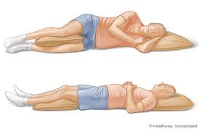
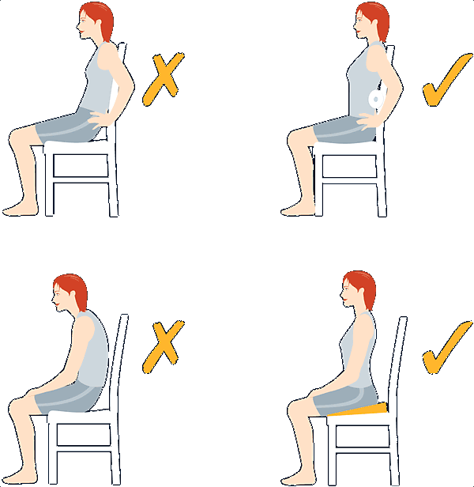

- Try to do exercises each and every day, and do not forget that exercise while you are setting in front of the computer..
** you should seek hospital if the pain was continuous and not relived by life style modification & hot packs
We hope that you get some benefits from our survey, Thank you for your time.

- Afrah aljuhani and Reem batarfi

